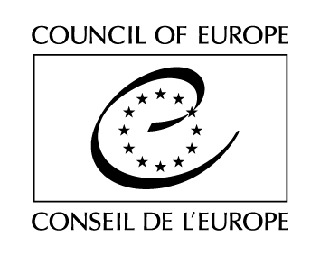

Strasbourg, 24 October 2018 GT-ED(2018)OJ1

EUROPEAN COMMITTEE ON DEMOCRACY AND GOVERNANCE
(CDDG)

WORKING GROUP ON E-DEMOCRACY
(GT-ED)

DRAFT AGENDA

Opening of the meeting: Tuesday 27 November 2018 at 9.30 am
Close of the meeting: Tuesday 27 November 2018 at 6.00 pm
Strasbourg, Council of Europe, Agora, Room G06

1. | Opening of the meeting by the Secretariat
2. | Election of the Chair and the Vice-Chair
3. | Adoption of the agenda | [GT-ED(2018)OJ1]
4. | CDDG working group: Terms of reference | [GT-ED(2018)1]
5. | Scope of the working groups’ activities  E-democracy: Critical analysis of  - Committee of Ministers’ Recommendation CM/Rec(2009)1 on electronic democracy (e-democracy);  - Latest developments in the field of e-democracy, in particular since the adoption of CM/Rec(2009)1;  - Potential benefits and advantages, technological issues and challenges and risks of e-democracy tools.  E-democracy, current rules, practice and expectations in member States:  - Contributions by the working group.  Exchange of views on the future guidelines on e-democracy | [GT-ED(2018)2]
6. | Conclusion
7. | Other business
8. | Date and place of the next meeting

